**Lab Exercise #1**

**Implementation of Toy Problem**

**Name: Sayan Pramanick**

**Reg. no: RA1811030010023**

**Title:**

Water and Jug

**Problem Description:**

If ‘fill’ liters of **water** are measurable, we must have ‘fill’ liters of **water** contained within one or both buckets by the end.

**Solution:**

Fill any of the jugs fully with **water**. Empty any of the jugs. Pour **water** from one **jug** into another till the other **jug** is completely full or the first **jug** itself is empty.

**Python Code:**

def pour(jug1, jug2,max1,max2,fill):

print(' ',jug2,'-----',jug1)

if jug2 is fill:

return

elif jug2 is max2:

pour(0, jug1,max1,max2,fill)

elif jug1 != 0 and jug2 == 0:

pour(0, jug1,max1,max2,fill)

elif jug1 is fill:

pour(jug1, 0,max1,max2,fill)

elif jug1 < max1:

pour(max1, jug2,max1,max2,fill)

elif jug1 < (max2 - jug2):

pour(0, (jug1 + jug2),max1,max2,fill)

else:

pour(jug1 - (max2 - jug2), (max2 - jug2) + jug2,max1,max2,fill)

max1, max2, fill = int(input("jug1 = ")),\

int(input("jug2 = ")), \

int(input("required fill = "))

print("JUG1\tJUG2")

if max1>max2:

max1, max2 = max2, max1

pour(0, 0,max1,max2,fill)

**Input and output:**

Input 1: JUG 1 CAPACITY

Input 2: JUG 2 CAPACITY

Input 3: REQUIRED FILL

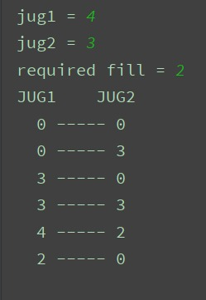

**Result:**

Thus the water and jug problem has been implemented successfully.